CURRICULUM VITAE
Personal Data:
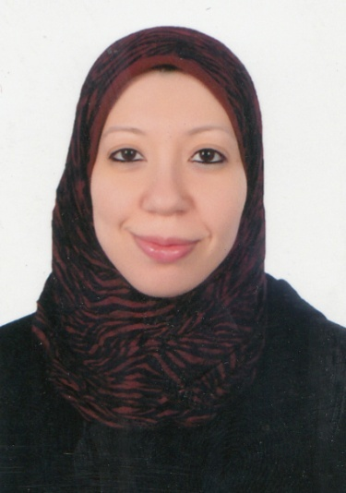
Name : Fatma Nabil Ahmed Mohamed
Gender : Female
Date of birth : 29/06/1982
Marital status : Married
Nationality : Egyptian
Address : Moalemeen - Street no 1 - Building no 99
Assiut- Egypt.
Telephone (Cell): (+2) 01003633992
E-mail address: fatmanabil2012@gmail.com

Current Position:
- Assistant lecturer in Anaesthesia and ICU department, Faculty of Medicine, Assiut University, Assiut, Egypt.

Positions Held:
- House officer, Assiut University Hospital: March 2008- February 2009.
- Resident of anaesthesia and ICU, Assiut University Hospital: March 2009 – February 2012.
- Assistant lecturer in Anaesthesia and ICU department, Faculty of Medicine, Assiut University, Assiut, Egypt: March 2012 till now.
Academic Qualifications:
- M.B.B.Ch. (excellent with honor degree), September 2007, Faculty of Medicine, Assiut University, Assiut, Egypt.
- Master degree in anesthesia and surgical intensive care (very good degree), June 2011, Faculty of Medicine, Assiut University, Assiut, Egypt.

Professional Registrations:
- Egyptian Medical Licence (March 2009).
- Member in the Egyptian Medical Syndicate (March 2009).

Researches:
- M.Sc. Thesis: Effect of intravenous vasopressor on fetal acid-base equilibrium during caesarean section done under regional anaesthesia "essay"

Summary of duties as an assistant lecturer in anaesthesia and ICU:
- Attending five operative schedules per week including all specialities of anaesthesia, supervising residents and under supervision of one of our staff members.
- Attending 10 afternoon and night shifts rotating between the intensive care units (General ICU, Obstetric ICU, Postoperative ICU, Paediatric congenital cardiac ICU and Trauma ICU) and emergency wards (Trauma unit and other surgical emergencies).

Staff Reference:
- Prof. Dr. Mohammed Mohammed Abdlatif: Professor and head of department of anaesthesia & ICU, Assiut University Hospitals (latif_mohamed@hotmail.com).
- Prof. Dr. Golnar Mohammad Fathy: Professor and former head of department of anaesthesia & ICU, Assiut University Hospitals (golnar_fathy@yahoo.com).
- Prof. Dr. Hany Ahmed Ibrahim Elmorabaa: Professor of anaesthesia & ICU, Assiut University Hospitals (elmorabaa@yahoo.com).
- Dr Essam Abdallah: Lecturer of anaesthesia & ICU, Consultant of cardiac anaesthesia, Assiut University Hospitals (esamel_deen@yahoo.com).
- Dr Sayed Kaood: Lecturer of anaesthesia & ICU, Consultant of cardiac anaesthesia, Assiut University Hospitals (sayed_k_72@yahoo.com).

